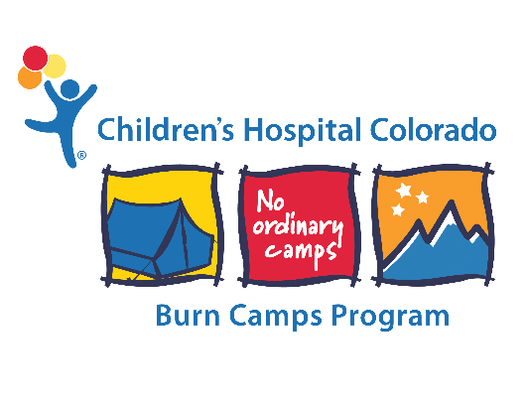

Please upload a copy of your current certification(s). Examples include, EMS, Nursing, Wilderness First Aid, First Aid, etc.

